# 1 INTRODUCTION

In recent years, robotics is a current emerging technology in the field of science. A number of universities in the world are developing new things in this field. Robotics is the new booming field, which will be of great use to society in the coming years. Though robots can be a replacement to humans, they still need to be controlled by humans itself. Robots can be wired or wireless, both having a controller device. Both have pros and cons associated with them. Beyond controlling the robotic system through physical devices, recent method of gesture control has become very popular. The main purpose of using gestures is that it provides a more natural way of controlling and provides a rich and intuitive form of interaction with the robotic system. These days many types of wireless robots are being developed and are put to varied applications and uses.

This project explains you how a bot is controlled wirelessly by using Wi-Fi module ESP8266.The Wi-Fi module is fully programmable, allowing us to use it as a microcontroller and manipulate inputs and outputs.

Here, we are going to use the onboard processor of the ESP8266 to host a small web server that will generate a simple interface on a webpage from which you will be able to control the bot. And we will even make this interface responsive, so it can also be used with your phone or tablet.

# 2 BLOCK DIAGRAM

L293D

MOTOR

ESP8266

Fig 1:Block diagram

# 3 HARDWARE USED

# 3.1 ESP8266

The ESP8266 is a low-cost Wi-Fi chip with full TCP/IP stack and microcontroller capability.

Espressif Systems Smart Connectivity Platform (ESCP) is a set of high performance, high integration wireless SOCs, designed for space and power constrained mobile platform designers. It provides unsurpassed ability to embed WiFi capabilities within other systems, or to function as a standalone application, with the lowest cost, and minimal space requirement.

ESP8266E offers a complete and self-contained WiFi networking solution. It can be used to host the application or to offload WiFi networking functions from another application processor.

When ESP8266 hosts the application, it boots up directly from an external flash. In has integrated cache to improve the performance of the system in such applications.

Alternately it also serves as a WiFi adapter and wireless internet access can be added to any microcontroller- based design with simple connectivity (SPI/SDIO or I2C/UART interface).

ESP8266 is among the most integrated WiFi chip in the industry. It integrates the antenna switches, RF balun, power amplifier, low noise receive amplifier, filters, power management modules, it requires minimal external circuitry, and the entire solution, including front-end module, is designed to occupy minimal PCB area.

ESP8266 also integrates an enhanced version of Tensilica’s L106 Diamond series 32-bit processor, with on-chip SRAM, besides the WiFi functionalities. ESP8266 is often integrated with external sensors and other application specific devices through its GPIOs; sample codes for such applications are provided in the software development kit (SDK).

3.1.1 FEATURES OF ESP8266

* 802.11 b/g/n
* Integrated low power 32-bit MCU
* Integrated 10-bit ADC
* Integrated TCP/IP protocol stack
* Integrated TR switch, balun, LNA, power amplifier and matching network
* Integrated PLL, regulators, and power management units
* Supports antenna diversity
* WiFi 2.4 GHz, support WPA/WPA2
* Support STA/AP/STA+AP operation modes
* Support Smart Link Function for both Android and iOS devices
* SDIO 2.0, (H) SPI, UART, I2C, I2S, IR Remote Control, PWM, GPIO
* STBC, 1x1 MIMO, 2x1 MIMO
* A-MPDU & A-MSDU aggregation & 0.4s guard interval
* Deep sleep power <10uA, Power down leakage current < 5uA
* Wake up and transmit packets in < 2ms
* Standby power consumption of < 1.0mW (DTIM3)
* +20 dBm output power in 802.11b mode
* Operating temperature range -40C ~ 125C
* FCC, CE, TELEC, WiFi Alliance, and SRRC certified

## 3.1.2 MAJOR FIELDS OF ESP8266 APPLICATIONS

* Home Appliances
* Home Automation
* Smart Plug and lights
* Mesh Network
* Industrial Wireless Control
* Baby Monitors
* IP Cameras
* Sensor Networks
* Wearable Electronics
* WiFi Location-aware Devices
* Security ID Tags
* WiFi Position System Beacons

## 3.1.3 PIN DIAGRAM OF ESP8266

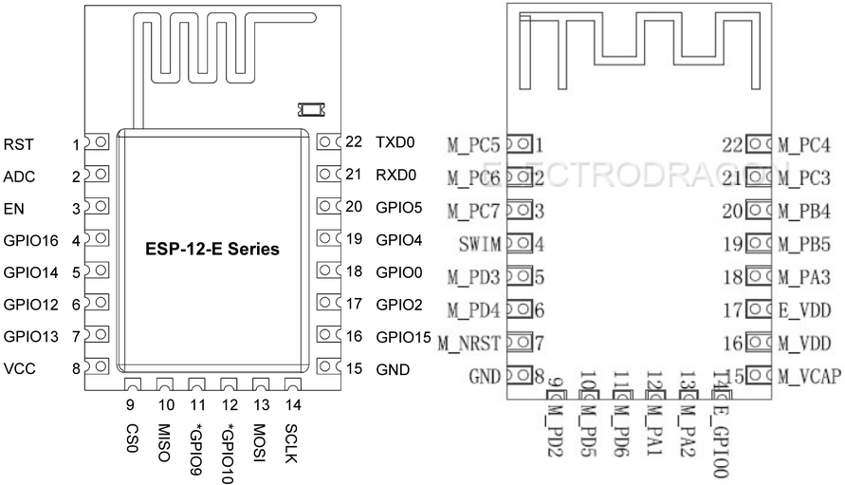

Fig 2: Pin Diagram of ESP8266

The Development Kit based on ESP8266, integrates GPIO, PWM, IIC, 1-Wire and ADC all in one board. Power your development in the fastest way combination with NodeMCU Firmware.

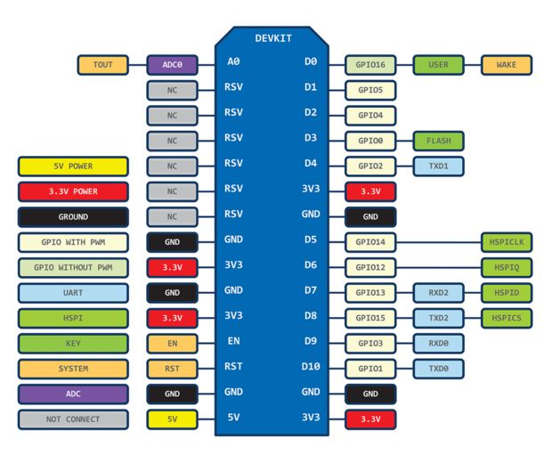

Fig 3: Pin Diagram of ESP8266

**3.2MOTOR DRIVER L293D**

L293D is a dual H-bridge motor driver integrated circuit (IC). Motor drivers act as current amplifiers since they take a low-current control signal and provide a higher-current signal. This higher current signal is used to drive the motors.

L293D contains two inbuilt H-bridge driver circuits. In its common mode of operation, two DC motors can be driven simultaneously, both in forward and reverse direction. The motor operations of two motors can be controlled by input logic at pins 2 & 7 and 10 & 15. Input logic 00 or 11 will stop the corresponding motor. Logic 01 and 10 will rotate it in clockwise and anticlockwise directions, respectively.

Enable pins 1 and 9 (corresponding to the two motors) must be high for motors to start operating. When an enable input is high, the associated driver gets enabled. As a result, the outputs become active and work in phase with their inputs. Similarly, when the enable input is low, that driver is disabled, and their outputs are off and in the high-impedance state.

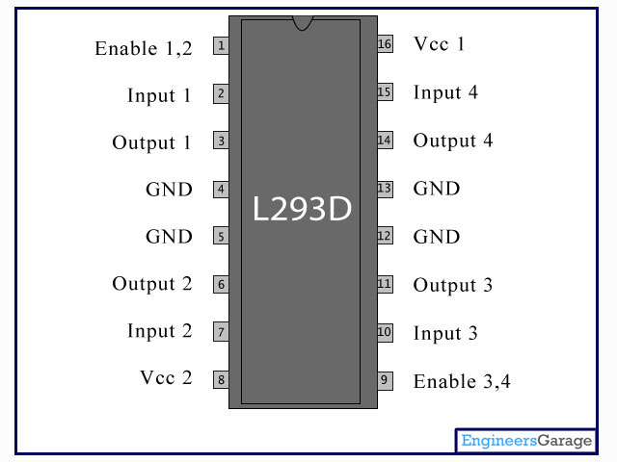

Fig 4: Pin Diagram of L293D

|  |  |  |
| --- | --- | --- |
| PIN NO | NAME | FUNCTION |
| 1 | Enable1,2 | Enable pin for Motor1 active high |
| 2 | Input 1 | Input 1 for Motor 1 |
| 3 | Output 1 | Output 1 for Motor 1 |
| 4 | Ground | Ground (0V) |
| 5 | Ground | Ground (0V) |
| 6 | Output 2 | Output 2 for Motor 1 |
| 7 | Input 2 | Input 2 for Motor 1 |
| 8 | Vcc 2 | Supply voltage for Motors; 9-12V (up to 36V) |
| 9 | Enable 3,4 | Enable pin for Motor2 active high |
| 10 | Input 3 | Input 1 for Motor 1 |
| 11 | Output 3 | Output 1 for Motor 1 |
| 12 | Grond | Ground (0V) |
| 13 | Ground | Ground (0V) |
| 14 | Output 4 | Output 2 for Motor 1 |
| 15 | Input 4 | Input 2 for Motor 1 |
| 16 | Vcc 1 | Supply voltage 5V (up to 36V) |

Table1: Function of L293D

3.3 PERMANENT MAGNET DC MOTOR

In a DC motor, an armature rotates inside a magnetic field. Basic working principle of DC motor is based on the fact that whenever a current carrying conductor is placed inside a magnetic field, there will be mechanical force experienced by that conductor.

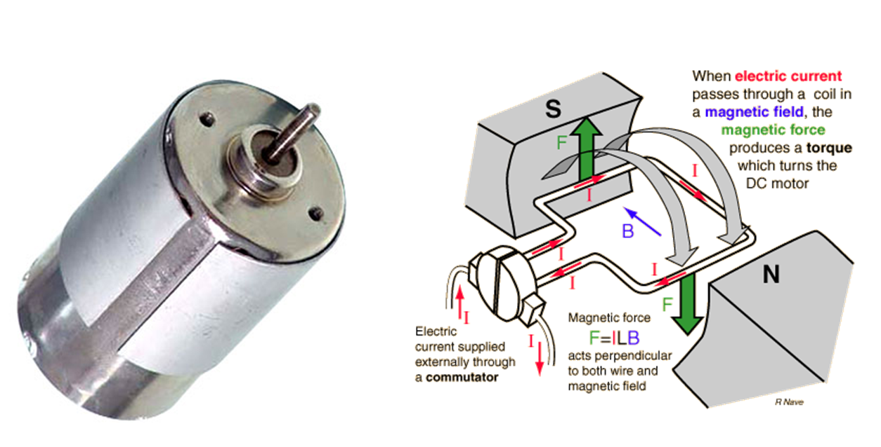

Fig 5: Working principle PMDC MOTOR

**4 PROTOCOLS USED**

**4.1 LOCAL AREA NETWORK**

A local area network (LAN) [Fig 5] is a computer network that interconnects computers within a limited area such as a school, laboratory, university campus office building or an industry and has its network equipment and interconnects locally managed. Ethernet and Wi-Fi are the two most common transmission technologies in use for local area networks.

[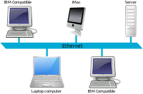](https://en.wikipedia.org/wiki/File:Ethernet_LAN.svg)

Fig 6: A conceptual diagram of a local area network.

**4.1.1 WIRED MEDIA**

Early LAN cabling had generally been based on various grades of coaxial cable. This led to the development of 10BASE-T (and its successors) and structured cabling which is still the basis of most commercial LANs today.

**4.1.2 WIRELESS MEDIA**

Many LANs are now based partly or wholly on wireless technologies. Smartphones, tablet computers and laptops typically have wireless networking support built-in. In a wireless local area network, users may move unrestricted in the coverage area. Wireless networks have become popular in residences and small businesses, because of their ease of installation. Guests are often offered Internet access via a hotspot service.

**4.1.3 TECHNICAL ASPECTS**

Network topology describes the layout of interconnections between devices and network segments. At the Data Link Layer and Physical Layer, a wide variety of LAN topologies have been used, including ring, bus, mesh and star, but the most common LAN topology in use today is switched Ethernet. At the higher layers, NetBEUI, IPX/SPX, AppleTalk and others were once common, but the Internet Protocol Suite(TCP/IP) is now the standard.

**4.2 HYPERTEXT TRANSFER PROTOCOL**

The Hypertext Transfer Protocol (HTTP) is an application protocol for distributed, collaborative, hypermedia information systems. HTTP is the foundation of data communication for the World Wide Web. Hypertext is structured text that uses logical links (hyperlinks) between nodes containing text. HTTP is the protocol to exchange or transfer hypertext.

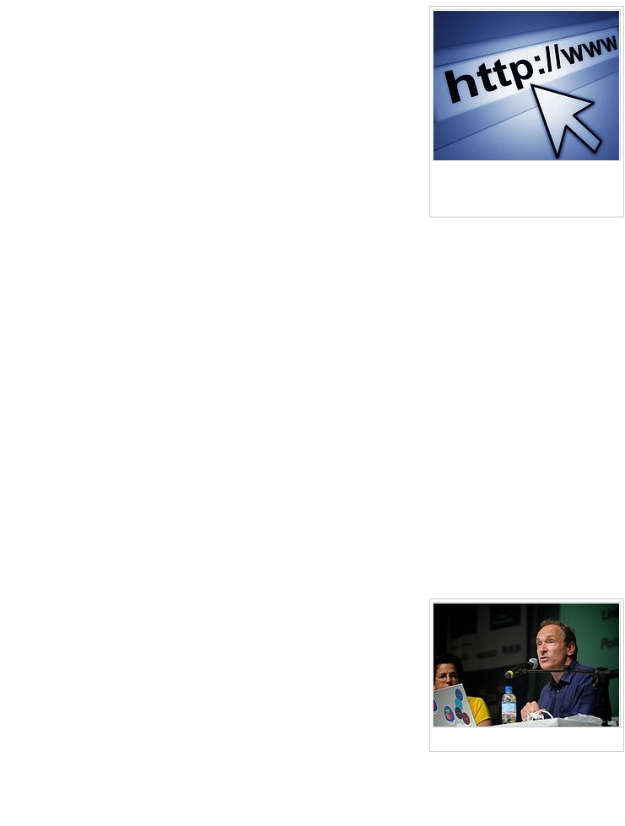

Fig7: A website URL starting with http

**4.2.1 WORKING OF HTTP PROTOCOL**

HTTP functions as a request–response protocol in the client–server computing model. A web browser, for example, may be the client and an application running on a computer hosting a web site may be the server. The client submits an HTTP request message to the server. The server, which provides resources such as HTML files and other content, or performs other functions on behalf of the client, returns a response message to the client. The response contains completion status information about the request and may also contain requested content in its message body.

A web browser is an example of a user agent (UA). Other types of user agent include the indexing software used by search providers (web crawlers), voice browsers, mobile apps, and other software that accesses, consumes, or displays web content.

# 5 SOFTWARE USED

**5.1 ARDUINO IDE**

The Arduino Integrated Development Environment - or Arduino Software (IDE) - contains a text editor for writing code, a message area, a text console, a toolbar with buttons for common functions and a series of menus. It connects to the Arduino and Genuino hardware to upload programs and communicate with them.

**5.1.1 WRITING SKETCHES**

Programs written using Arduino Software (IDE) are called **sketches**. These sketches are written in the text editor and are saved with the file extensionino. The editor has features for cutting/pasting and for searching/replacing text. The message area gives feedback while saving and exporting and also displays errors. The console displays text output by the Arduino Software (IDE), including complete error messages and other information. The bottom right hand corner of the window displays the configured board and serial port. The toolbar buttons allow you to verify and upload programs, create, open, and save sketches, and open the serial monitor.

GotoFile-->Preferencesandaddthelinkhttp://arduino.esp8266.com/stable/package

_esp8266com_index. json totheAdditional Boards Manager URLS.

* Go to Tools --> Board --> Boards manager
* You should now have the esp8266 as an option there since you've added it to the Additional Boards. Select it and press Install
* Now, you have the ESP8266 boards configure. Choose the board you have, "Generic ESP8266 Module" if you got the regular module.
* Select the COM port to which the ESP8266 board is connected via the UART to USB bridge. The COM port can be identified by looking into device manager in Windows Operating System.

**5.2HYPERTEXT MARKUP LANGUAGE**

Hypertext Markup Language, commonly abbreviated as HTML, is the standard markup language used to create web pages. HTML elements form the building blocks of HTML pages. HTML allows images and other objects to be embedded and it can be used to create interactive forms.

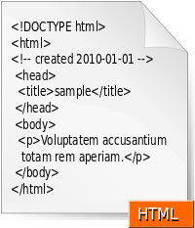

Fig 8:HTML Org Icon

It provides a means to create structured documents by denoting structural semantics for text such as headings, paragraphs, lists, links, quotes and other items. HTML elements are delineated by tags, written using angle brackets [Fig 8].

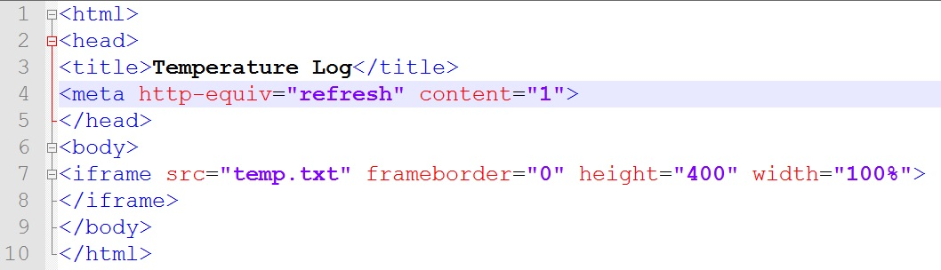

Fig 9: An example website written in HTML Code

HTML is a markup language that web browsers use to interpret and compose text, images, and other material into visual or audible web pages. Default characteristics for every item of HTML markup are defined in the browser.

# 6 WORKING

TheESP8266 is made tohostasmallweb server in the local area network,thatwillgenerateasimpleinterfaceonawebpagefromwhichyouwillbeableto controlthe bot. The HTML code for the web page can be programmed in ESP8266 with the help of Arduino IDE.

TheESP8266willhavetohandle requestscomingfromyourbrowser,displayasimpleHTMLpagewithtwobuttons(On& Off),andthencontroltherelayaccordingly.AsweareusingtheArduinoIDEtoprogram ourESP8266wewillalsobeusingthewell-knownArduinolanguageforthispart. The ESP8266 should be connected with the local area network. It can be connected by providing the ssid and password for the Local Area Network in the Arduino code.

Whenever the user wants to control the bot, he has to login in to local IP address of ESP 8266 in any web browser, provided the computer or android phone in which the browser is, must be connected to the Local Area Network same as that of ESP8266. After logging the HTML page will be loaded and the user can find buttons for controlling the bot in it. He can click any button on the webpage which will make the bot to move in respective directions.

# REFERENCES:

* https://github.com/esp8266/Arduino/blob/master/libraries/ESP8266WebServer/examples/HelloServer/HelloServer.ino
* https://github.com/nodemcu/nodemcu-firmware
* http://blog.nyl.io/esp8266-motor/
* http://esp8266.ru/esplorer/
* https://www.arduino.cc/en/Guide/Environment#thirdpartyhardware
* http://www.engineersgarage.com/electronic-components/l293d-motor-driver-ic